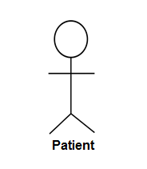**Use case diagram of Health Care Consultant**